INTERNEE.PK — CYBERSECURITY INTERNSHIP

Task 6: Security Audit of Internee.pk's Website
Penetration Testing & Vulnerability Assessment Report
Prepared By | Soban Shehzad
University | University of Education, Lahore
Internship Provider | Internee.pk — Cybersecurity Internship Program
Task | Task 6 — Security Audit of Internee.pk's Website
Date | October 8, 2026

Introduction
I am Soban, a Cybersecurity Intern at Internee.pk. This report documents my work on Task 6: Security Audit of Internee.pk's Website, which required identifying vulnerabilities and assessing data protection on a web application. As instructed in the task guidelines, testing was carried out against OWASP Juice Shop, a deliberately vulnerable application used in place of the live Internee.pk staging site, using OWASP ZAP for automated scanning and manual testing for SQL injection, XSS, and CSRF.

Objective
This audit identifies security vulnerabilities affecting authentication, input handling, and data protection, in line with the internship task to assess Internee.pk's website for common web application risks (SQL injection, XSS, CSRF) and misconfigurations.

Scope & Methodology
Testing was performed against OWASP Juice Shop, a deliberately vulnerable web application, used as the staging target recommended in the task guidelines in place of the live Internee.pk environment.
Tools used:
- OWASP ZAP 2.17.0 (automated scanning)
- Manual testing via browser (SQL injection, XSS)
Testing approach:
- Automated Scan (spider + active scan) against http://localhost:3000 using ZAP's Dev Standard policy.
- Manual penetration testing of the login page, search bar, and account/API endpoints for SQL injection, XSS, and CSRF.
- Review of ZAP's passive alerts for configuration-level weaknesses (headers, CORS, information disclosure).

Summary of Findings
# | Finding | Risk | Location
1 | SQL Injection (authentication bypass) | High | Login page
2 | DOM-based Cross-Site Scripting (XSS) | High | Search bar
3 | CSRF protection (JWT-based) | Informational | Account/session handling
4 | Content Security Policy (CSP) header not set | Medium | Site-wide
5 | Cross-Domain Misconfiguration (CORS) | Medium | /scripts.js
6 | Timestamp Disclosure | Low | /styles.css
7 | Modern Web Application (informational) | Informational | /sitemap.xml

Finding 1: SQL Injection — Authentication Bypass (High)
Location: Login page (/#/login)
Payload: ' OR 1=1-- entered in the email field, with any value in the password field
Result: The application logged the tester in as the administrator (admin@juice-sh.op) without a valid password.
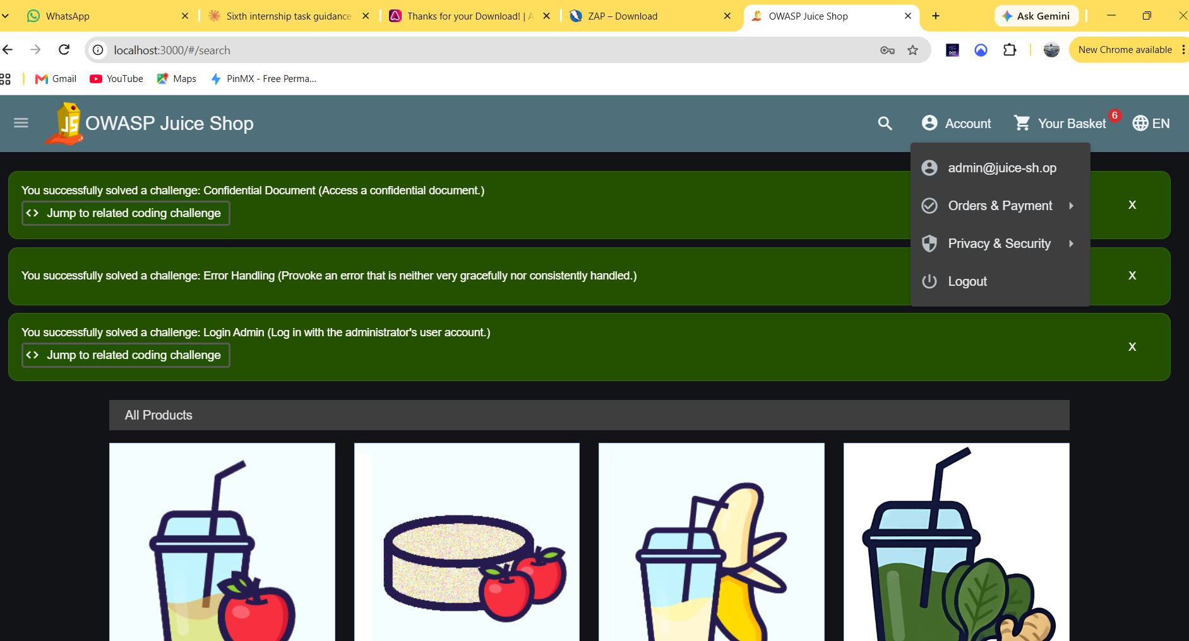
Root cause: User input is concatenated directly into the SQL query used to validate login credentials. The payload closes the string literal and forces the WHERE clause to always evaluate true, returning the first matching user record regardless of password.
Impact: Full authentication bypass. An attacker can log in as any user, including administrators, without credentials, leading to complete account takeover and access to sensitive data.
Recommendation: Use parameterized queries / prepared statements for all database access, and never concatenate user input directly into SQL strings. Apply input validation and least-privilege database accounts as defense in depth.

Finding 2: DOM-based Cross-Site Scripting (High)
Location: Search bar (/#/search?q=)
Payload: <iframe src="javascript:alert('XSS')">
Result: The browser executed the injected script, displaying a JavaScript alert box. A simple <script> tag was blocked by the browser, but the iframe payload bypassed this protection.
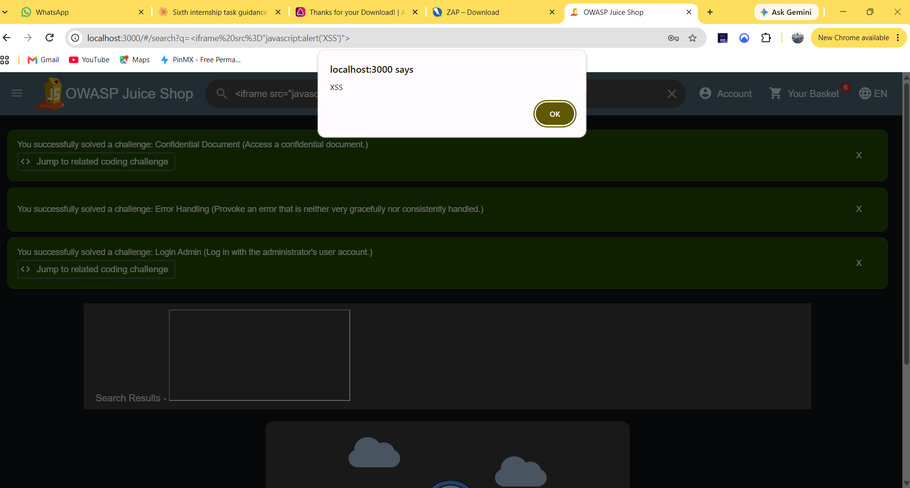
Root cause: The search query is reflected into the page's DOM without proper sanitization or output encoding, allowing injected HTML/JavaScript to execute in the context of the site.
Impact: An attacker could craft a malicious search URL and trick a victim into clicking it (e.g. via email or chat), executing arbitrary JavaScript in the victim's browser. This can be used to steal session tokens/cookies, redirect users to phishing pages, or perform actions on their behalf.
Recommendation: Sanitize and encode all user-supplied input before rendering it in the DOM. Apply a strict Content Security Policy (see Finding 4) as an additional layer of defense against script injection.

Finding 3: CSRF Protection (Informational)
Location: Account/session handling
Observation: The application authenticates requests using JWT bearer tokens sent in request headers, rather than cookies. No traditional CSRF tokens were found on state-changing forms.
Assessment: Because the JWT is not automatically attached by the browser (unlike cookies), a third-party site cannot forge authenticated requests on a victim's behalf in the classic CSRF pattern. This design choice meaningfully reduces CSRF risk.
Recommendation: Continue using header-based bearer tokens rather than cookie-based sessions for authenticated API calls. If cookies are ever introduced for session handling, CSRF tokens or SameSite cookie attributes should be added at that time.

Findings 4–7: Automated Scan Results (OWASP ZAP)

Finding 4: Content Security Policy (CSP) Header Not Set — Medium
URL: http://localhost:3000 Description: No CSP header is set, so the browser has no restriction on which scripts, styles, or other resources the page may load. This increases the impact of XSS and data injection attacks. Recommendation: Configure the web/application server to send a Content-Security-Policy header restricting allowed sources for scripts, styles, and other content.
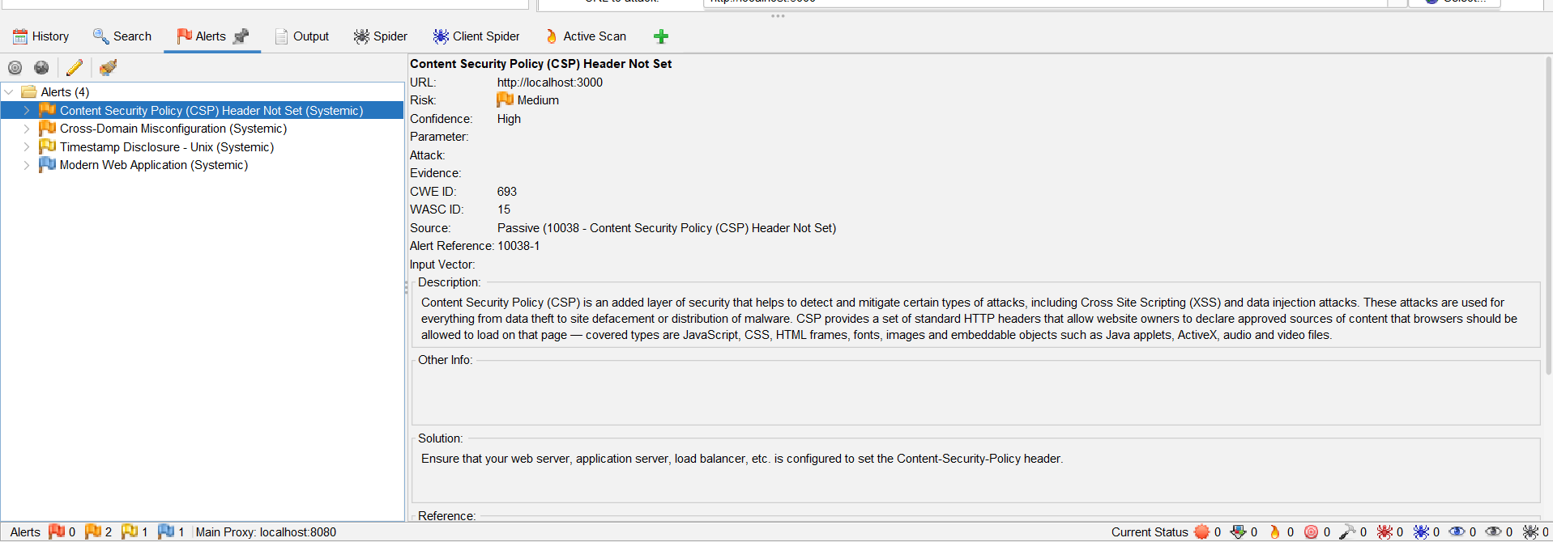

Finding 5: Cross-Domain Misconfiguration (CORS) — Medium
URL: http://localhost:3000/scripts.js Evidence: Access-Control-Allow-Origin: * Description: The server allows cross-origin requests from any domain, which could let a malicious third-party site read responses from authenticated APIs. Recommendation: Restrict Access-Control-Allow-Origin to a trusted set of domains, or remove the header where cross-origin access is not required.
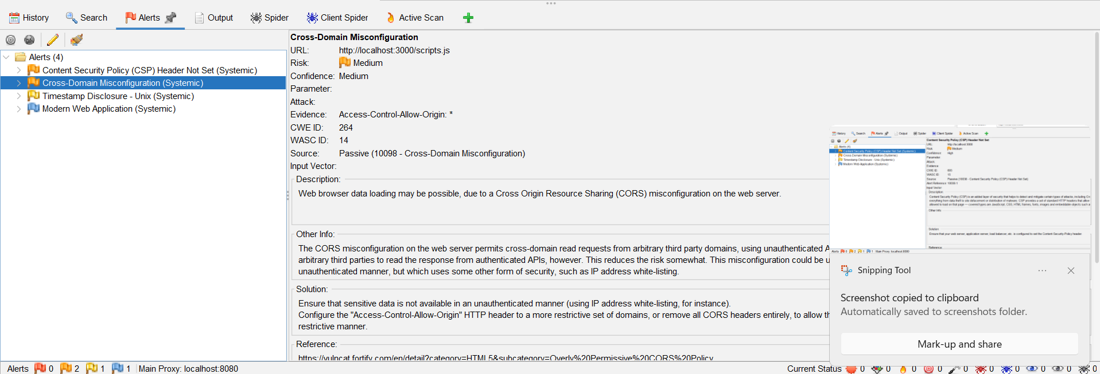

Finding 6: Timestamp Disclosure — Low
URL: http://localhost:3000/styles.css Evidence: 1528301887 (evaluates to 2018-06-06 21:18:07) Description: A Unix timestamp is exposed in a static resource, a minor information leak. Recommendation: Confirm the timestamp is not sensitive and cannot be used to infer exploitable patterns; remove if unnecessary.
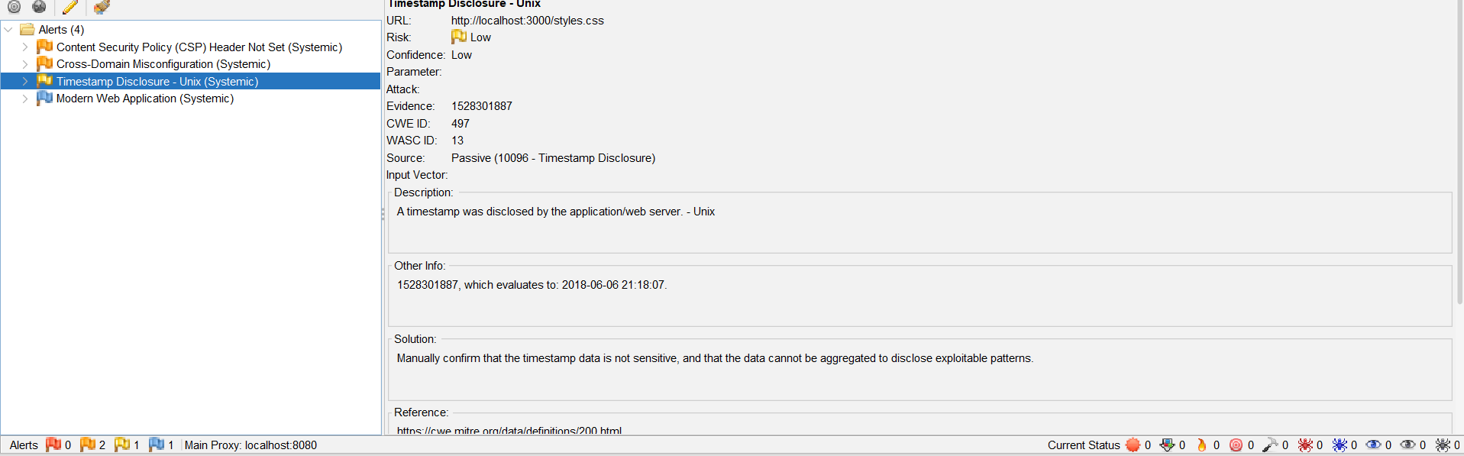

Finding 7: Modern Web Application — Informational
URL: http://localhost:3000/sitemap.xml Description: Passive note that the site is a modern JavaScript-driven application; not a vulnerability. Noted for completeness.
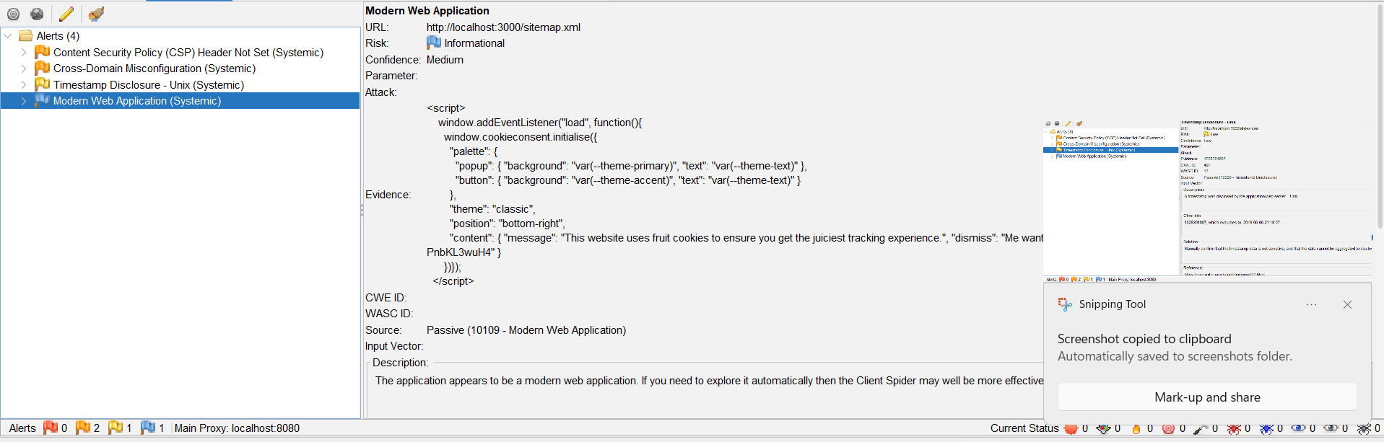

Conclusion & Recommendations
The audit identified two high-risk vulnerabilities (SQL Injection and DOM-based XSS) that allow authentication bypass and arbitrary script execution, alongside medium and low-risk configuration weaknesses. Recommended priority order:
- Fix SQL Injection by switching to parameterized queries (highest priority — direct authentication bypass).
- Fix XSS by sanitizing/encoding reflected user input.
- Add a Content Security Policy header to reduce the impact of any future injection flaws.
- Restrict the CORS policy to trusted origins.
- Remove unnecessary timestamp disclosure in static assets.
CSRF risk is currently low due to the JWT-based authentication design and does not require immediate action.

